**Cassandra Retrieving Sorting**

Creating Keyspace

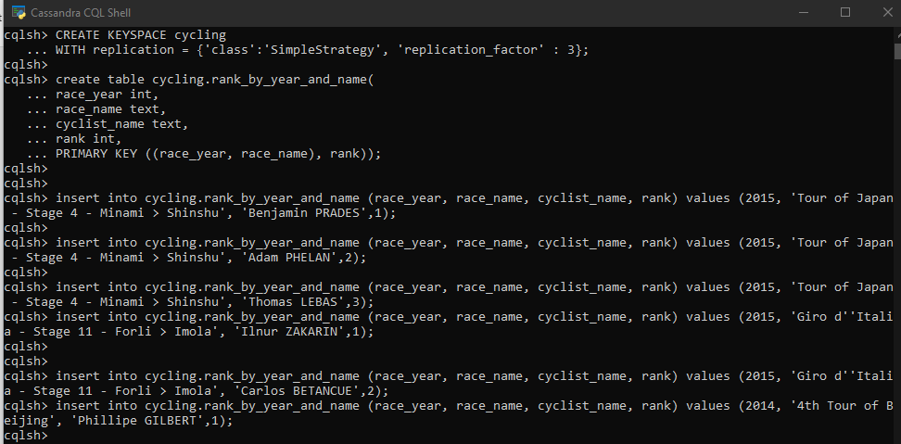

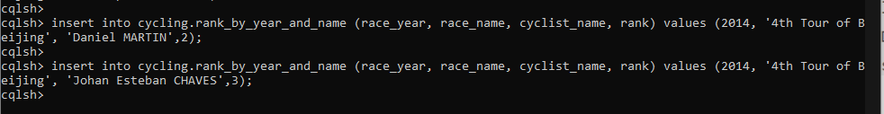

Displaying Table

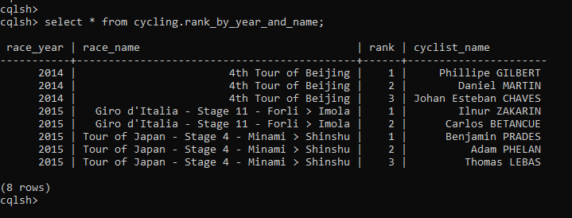

Querying

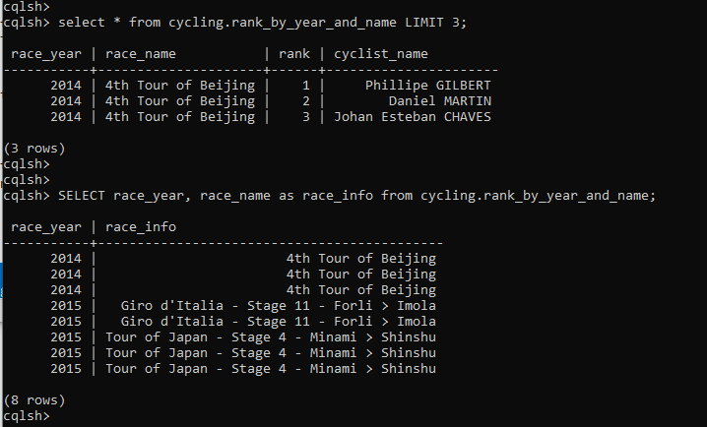

**CODES**

CREATE KEYSPACE cycling

WITH replication = {'class':'SimpleStrategy', 'replication_factor' : 3};

create table cycling.rank_by_year_and_name(

race_year int,

race_name text,

cyclist_name text,

rank int,

PRIMARY KEY ((race_year, race_name), rank));

insert into cycling.rank_by_year_and_name (race_year, race_name, cyclist_name, rank) values (2015, 'Tour of Japan - Stage 4 - Minami > Shinshu', 'Adam PHELAN',2);

insert into cycling.rank_by_year_and_name (race_year, race_name, cyclist_name, rank) values (2015, 'Tour of Japan - Stage 4 - Minami > Shinshu', 'Thomas LEBAS',3);

insert into cycling.rank_by_year_and_name (race_year, race_name, cyclist_name, rank) values (2015, 'Giro d''Italia - Stage 11 - Forli > Imola', 'Ilnur ZAKARIN',1);

insert into cycling.rank_by_year_and_name (race_year, race_name, cyclist_name, rank) values (2015, 'Giro d''Italia - Stage 11 - Forli > Imola', 'Carlos BETANCUE',2);

insert into cycling.rank_by_year_and_name (race_year, race_name, cyclist_name, rank) values (2014, '4th Tour of Beijing', 'Phillipe GILBERT',1);

insert into cycling.rank_by_year_and_name (race_year, race_name, cyclist_name, rank) values (2014, '4th Tour of Beijing', 'Daniel MARTIN',2);

insert into cycling.rank_by_year_and_name (race_year, race_name, cyclist_name, rank) values (2014, '4th Tour of Beijing', 'Johan Esteban CHAVES',3);

select * from cycling.rank_by_year_and_name;

select * from cycling.rank_by_year_and_name LIMIT 3;

SELECT race_year, race_name as race_info from cycling.rank_by_year_and_name;